Public Community Member Distribution

Users  - Primary  - Visitors  - Secondary | Phase 1
Intended Outcome
- Visitors interact with community they select as they are served with community profile
Links
- Figma
- https://trello.com/c/FxmkJ2BY/15-draft-build-public-community-members
- …
- …
- …

Introduction
Public Community Members introduces a dedicated section on each community’s public profile, allowing visitors to understand the unique identities, backgrounds, and distribution of its members. For example, in alumni-driven organizations like PPJIU, prospective joiners can see how many members come from each cohort, school, or held specific roles within the organization—such as selection year, school origin, or duty position in Paskibraka. By showcasing these granular traits, Kolavo helps visitors identify kindred backgrounds and feel a direct sense of belonging before joining. This increases both community credibility and motivates new members to connect with organizations where they recognize part of their own journey.

Product Requirement
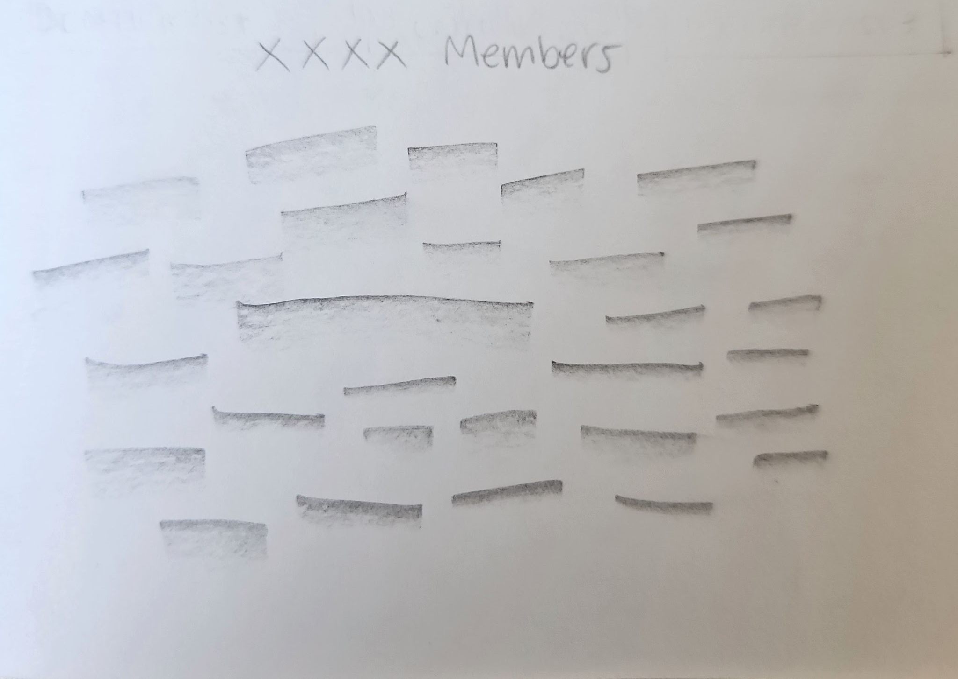
Member Distribution Sketch
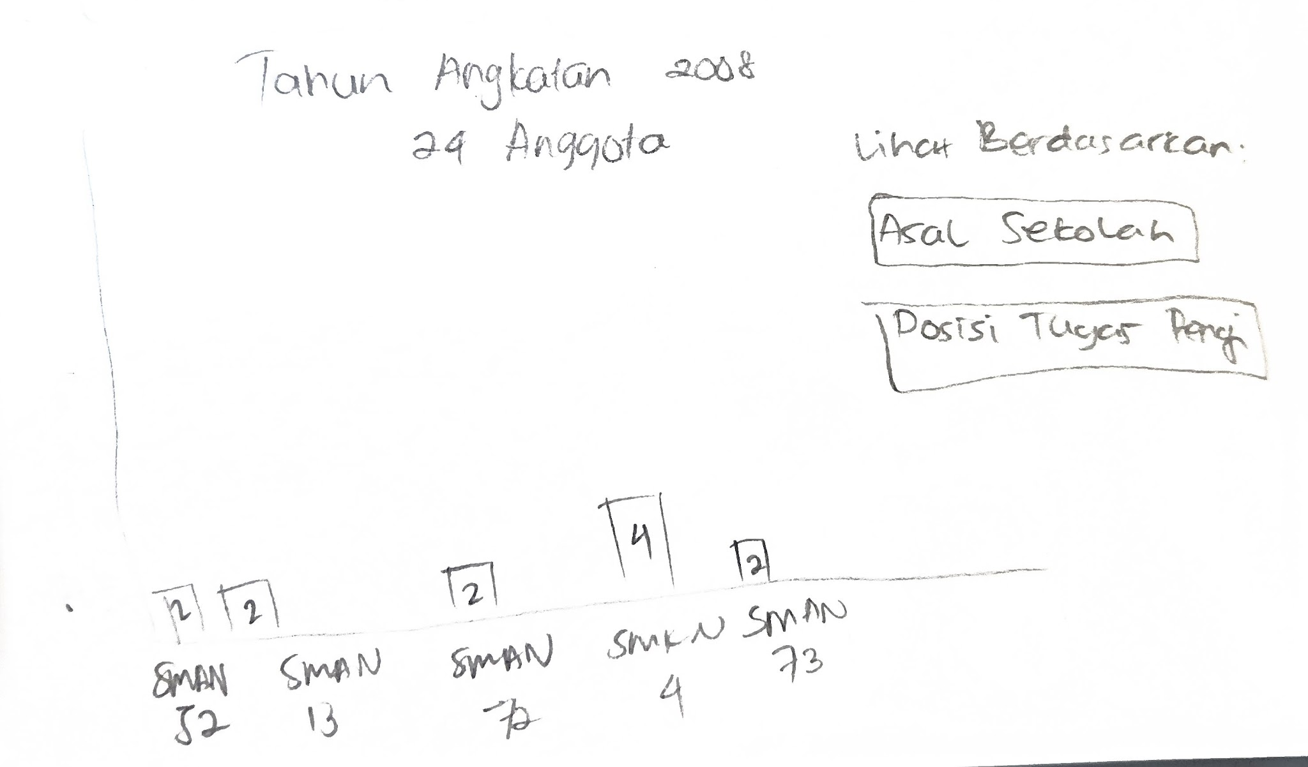
Member Distribution Chart Sketch

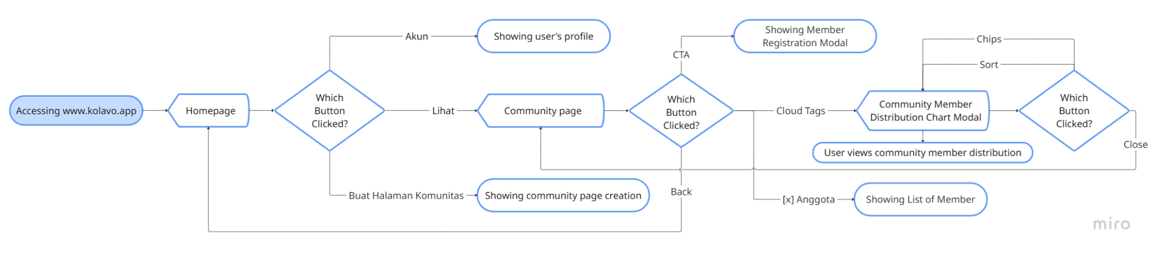
Flow Of Viewing Community Members Section Including Community Membership Distribution

No | User story | Scope | Acceptance Criteria
1 | As a visitor who sees my community profile exists in Kolavo, I want to know how many and what kind of members have joined, in a fun way so I can enjoy while looking at numbers | Attractive and playful community member distribution | - The public community profile page displays a members section with a visually engaging, playful presentation of member distributions.  - Member counts by key identity are clearly shown in a way that makes large numbers feel positive and lively, not overwhelming or dry.  - At least one playful visual element is present in the member section.  - Number of total member can be scanned at a glance without requiring clicks or navigation.  - The presentation works responsively (on both desktop and mobile) and does not become cluttered for very large communities.
2 | As a community manager, I want to see the member information that is uniquely part of my community, so that I can understand and communicate the composition of my organization. | Community’s context aggregated member distribution and breakdowns. | - The members section has a way to display aggregation (counts) for each of the key member identity fields defined in the community.  - The breakdowns are generated based on the actual identity schema of the community (not generic hardcoded fields).  - Each breakdown is labeled clearly and shows the count for each unique value.  - The totals and breakdowns are accurate and consistently updated as members join or leave.
3 | As visitors, I want to know the member information in the community page so I don’t need to click anything once I visit community page | Members section within community page | - The members section is immediately visible on the community page when a visitor lands, without requiring any clicks nor tabs.  - The member section is clearly separated from other sections through spacing or layout cues.  - No login or special permissions are required for visitors to see the aggregated member information.  - The section loads concurrently with the page and does not require an additional manual refresh or interaction.

Design Requirement

Member Headeing
Design Intent | To make visitor notice how big the community is
Content / Copy | Total member count displays: [Number of Member] Anggota
Visual Requirement
Interaction Behavior | - Number of member changes real time
Acceptance Criteria

Subhead
Design Intent | To spark visitor’s curiosity to check member distribution
Content / Copy | Intip di Sini 👀 or Cari Tahu di Sini 👇🏻
Visual Requirement
Interaction Behavior | - None
Acceptance Criteria

Member Distribution Tag Cloud (Interactive)
Design Intent | Let visitors grasp the diversity and depth of a community at a glance, invite playful exploration, and allow for deeper analysis with one click. The experience is lively, simple, and celebrates the uniqueness of member backgrounds using an organic tag/word cloud, rather than dry bar charts.
Content / Copy | - Maximum 10 tag cloud showed  - Each keyword represents a major member group or any other identity/dimension field configured by the community.
Visual Requirement
Interaction Behavior | - On click, the tag cloud stays visible but the bar chart view overlays within a modal  - Clicking another word switches the bar chart to a different category view
Acceptance Criteria

Modal Members Distribution Bar Chart
Design Intent | Enable visitors and members to discover the inner diversity of a community’s member group, getting rich breakdowns in a single, playful, intuitive chart.
Content / Copy | - Modal title: [Category Name] [Chosen Tag]  - Modal subtitle: [Number of member of chosen tag] Anggota  - Chips options title: Lihat berdasarkan:  - Chips label: [Sub category name]  - Sorting from the greatest function: Terbanyak  - Sorting from the least function: Tersedikit  - Bar title: [subgroup label]  - Bar number: [number per subgroup]
Visual Requirement
Interaction Behavior | - Modal opens when a tag is clicked in the tag cloud.  - Clicking sort function dynamically change the bar data and visual  - Clicking outside closes the modal (or a clear close icon is provided).  - Modal and chart responsive for mobile and desktop.
Acceptance Criteria

Engineering Requirement

Questions

